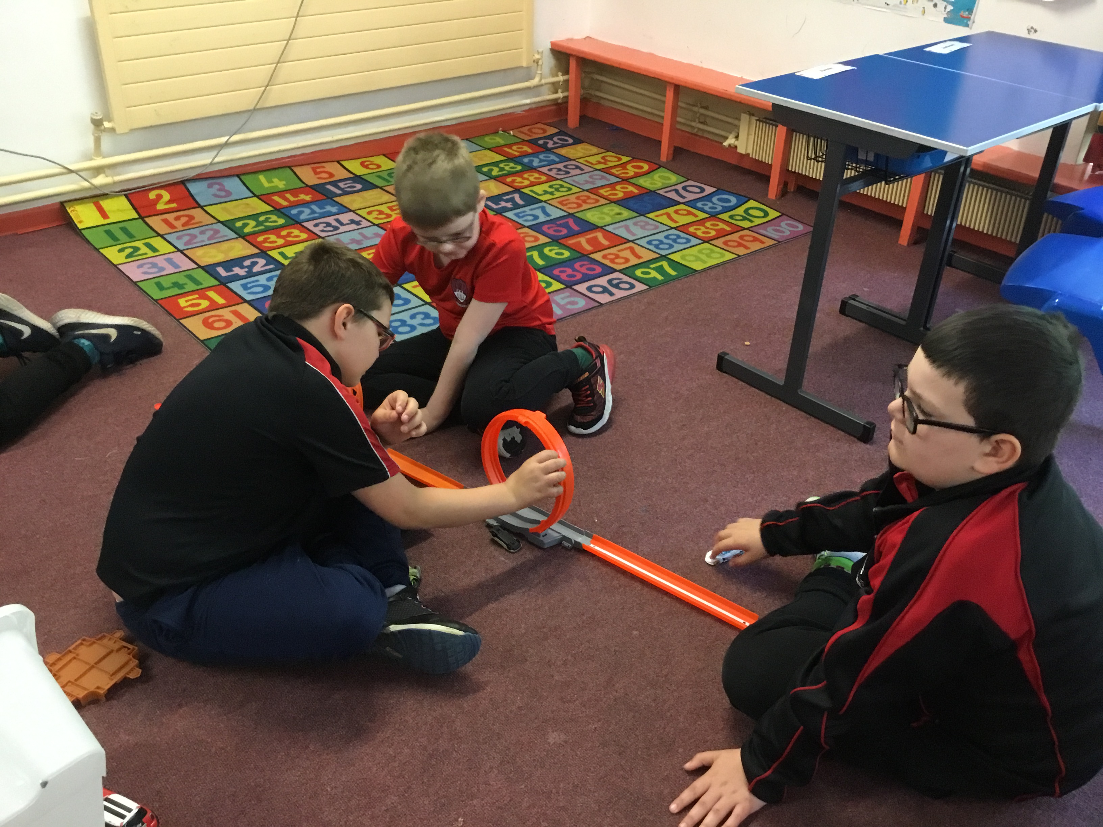
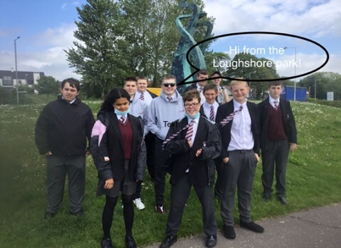
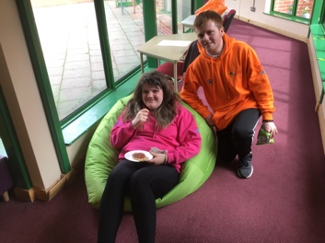
A big big thank you.

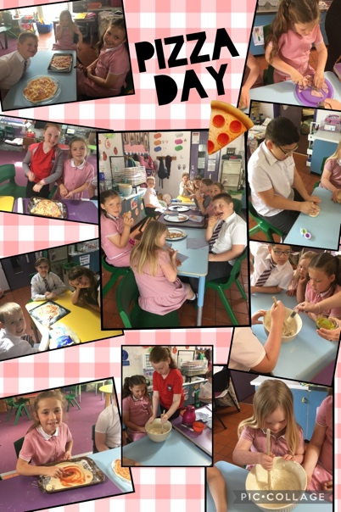
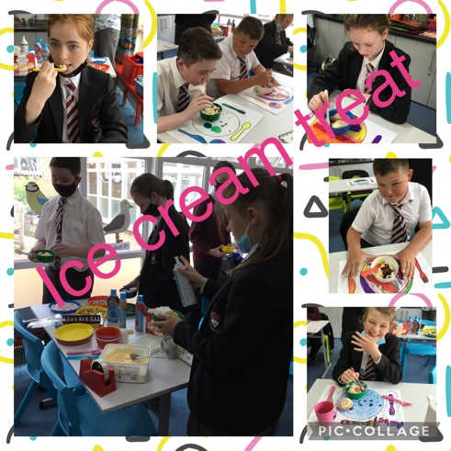
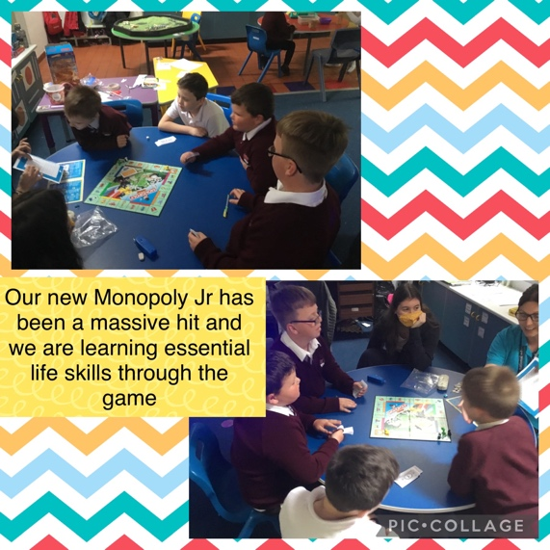
All the Rosstulla pupils would like to thank you, the parents and carers for the money you have contributed to our classes this year.

We have been able to use it to buy new games and equipment for our classrooms and of course enjoy some treats! Apart from having fun these extras help us develop our social skills in and out of the classroom. As you can see from the selection of photos, there were lots of edible treats! Sorry we don’t have room to show photos from every class.

