Raising a Concern

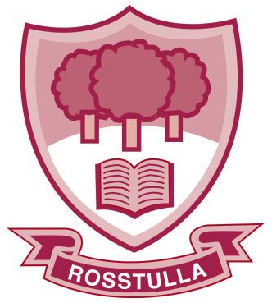

Rosstulla School

“Together Towards Tomorrow”

Agreed by the Governing Body September 2023

Chairperson's signature __________________________ Date: ___________

Statement of Ethos
At Rosstulla, we are committed to being a welcoming school in which everyone feels valued, respected and supported. We aim to provide a nurturing, inclusive learning environment where each child is enabled to reach their full potential. We will strive to develop the life skills each pupil needs to become a valued member of their community, celebrating individual success and achievement along the way.

Occasionally a parent/carer may not be happy with an issue or problem that has arisen in school and may wish to share their concerns.

In Rosstulla we take all concerns raised seriously and try to resolve them amicably, fairly and in the best interests of the child.

If you are raising a concern please observe the following:

- Staff and parents/carers have the right to be treated with respect. If you are feeling cross or upset, it may not be the best time to send a seesaw message, make a phone call or visit the school. Make sure when you are speaking to staff that you do so in a non- threatening manner. Staff have the right to end a meeting or telephone call that is aggressive or clearly failing to resolve the issue.

- Do not make the issue ‘personal’

- Do not discuss other pupils or their families- everyone has the right to confidentiality.

- Listen to the staff member and remain open minded.

-Try and address the concern with the right person for example;
-If it is about your child’s learning or well-being first point of contact is with the class teacher.
-If it is a safeguarding concern bring it to Mrs McCarthy, our Designated Teacher.
-If you have a concern about the class teacher or another member of staff bring it to the
Principal.

- Please note that where you have concerns regarding online activity at home, we cannot take responsibility, but will help and support to the best of our ability.

Key Contacts
School telephone number: 028 90862743
School e-mail: info@rosstullass.newtownabbey.ni.sch.uk

 | Who do I contact about my concern? | How do I make raise my concern?
1st point of contact | Form Teacher | Seesaw message  Telephone call  Meeting
2nd point of contact | Key Stage Co-ordinators  Early Years Miss McFarland  Primary Mrs McCoey  KS3 Mrs McCready  KS4&5 Mrs McCann | Telephone call  Meeting
3rd Point of contact | Departmental Leaders  Secondary: Miss Mitchell  Primary: Mr Owens | Telephone call  E-mail  Meeting
4th Point of contact | Vice-Principal/ Designated Teacher  Mrs McCarthy | Telephone call  E-mail  Meeting
5th point of contact | Principal  Miss Matchett | Telephone call  Email  Meeting
If your concern is not resolved | Formal Complaints Procedure | Stage 1 in writing to the Principal.  Stage 2 in writing to the Chair of Board of Governors.

Please remember that staff are busy and that they may not be able to take your call, respond to your message or phone you back immediately. Staff will not respond to you outside of their working hours. If you raise a concern with staff by e-mail it is likely that they will follow up with a phone call or invite you for a meeting as we find most concerns are best addressed face to face.

Staff may request that a line manager also be in attendance at a meeting to help in addressing your concerns.

If you want to speak to someone in person, please make an appointment through the school office
028 90862743

